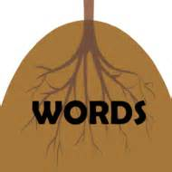
Vocabulary and Spelling

Teacher: Michelle Peters
Grades 5-8
Time: Semester 1, Mondays 2:30-3:30pm, 17 weeks
Cost: $125 + $10 copy fee
No book required.

This class will focus on vocabulary using Latin and Greek roots. We will include spelling by learning to spell our vocabulary words. Each week will focus on different root(s) and words stemming from that root(s). Each week, students will complete homework that go over the words for the week. In class, we will review the words, play games, and do activities that reinforce these words. We will take a quiz after every 3 lessons to make sure students are retaining what they are learning.

About the teacher: I graduated from Purdue University with a degree in Mathematics Education. I have taught grades 2-12 and even 1 semester of algebra at the college level. I also taught vocabulary to at-risk elementary in an after-school program for two years. This will be my 3rd year teaching at Wisdom Builders. I am married and have one daughter, Laura, who also attends WB.
Contact information: Michelle Peters
Email: petersjandm@yahoo.com
Phone: 317-457-5897

