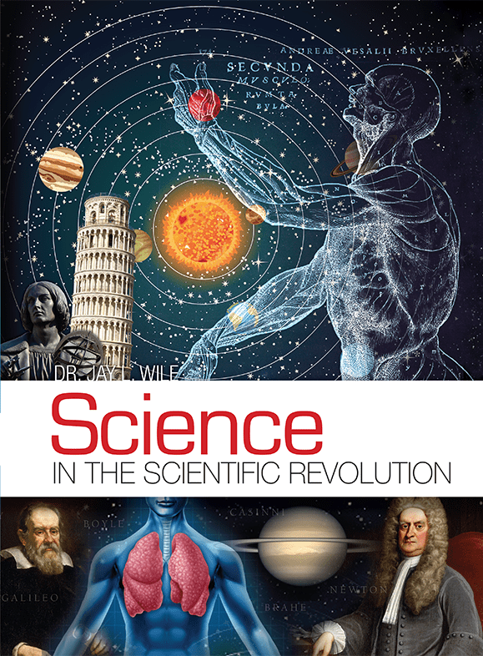
WB Elementary Science Lab
SCIENCE IN THE SCIENTIFIC REVOLUTION
Grades 2 through 6 with Mrs. Jan Eyster
4th-6th grades: Tues. 9:00
2nd-3rd grades: Tues 12:30
24 Week Trimester Class Cost: $120 per year
Supply Fee $15 per year

PLEASE NOTE: This is a core class, not an “elective” or enrichment class. It can be used as your Science for the school year. Students will need to read from the textbook at home BEFORE coming to class. (Syllabus provided, and you will get an email a couple weeks before school begins, because our first class, we will jump right in with Labs!) Parents from last year agreed that the reading was very doable, and Lessons were short.

We will begin class each week with a devotion from Louie Giglio's children's devotional book, "Indescribable", 100 Devotions About God and Science. Science naturally draws us back to how God created things and the wonder of how our universe is intimately designed and perfectly suited for mankind
After devotions, class time will consist of a short review of the reading material, then students will participate in 1-2 Science Labs each week that reinforce what they are learning.
Grades 2-3: Have fun with labs; Keep a simple Lab Notebook; no grades taken
Grades 4-6: Have fun with labs; will be graded on their Lab Notes, as well as
3- 4 quizzes each trimester

Materials required:
- Textbook: Science in the Scientific Revolution by Dr. Jay L. Wile, Publisher: Berean Builders (You will need to purchase your own)
- Recommend: Helps and Hints: Science in the Scientific Revolution (Booklet)
- Wisdom Builders BINDER, with a tab labeled “Science Lab”.
- Purchase a Composition Book (approx. 9"X 7") which will be their Science Lab Notebook (I like the fun ones with animals depicted!)
- A sharpened pencil, eraser, and colored pencils for sketches in Lab Notebook

My goal is to cover 3 lessons a week. Prior to class each week, students should have read the material (Class syllabus will list out what they need to read at home) We will review the lessons, and do labs that reinforce what they’ve read. As much as possible, I will select hands-on experiments from the lessons that are suitable for our one-hour class time.
(Continued)

Other experiments can be done at home, as well as the optional “challenge lessons” if you so desire. These challenge lessons are the ones listed in red ink in the Table of Contents, pages xv - xvii.
The following is a brief description of the material we will be covering.
Science in the Scientific Revolution is an engaging, exciting, hands-on, multilevel elementary resource that is the third in a planned series of books by Dr. Jay Wile.
Introducing scientific concepts in the context of history, students will follow the work of the scientists who lived during the period known as "The Scientific Revolution." Arranged chronologically, chapters focus both on concepts as well as thinkers, including Galileo & Heliocentrism, Descartes, Otto von Guericke and the Electrical Charge, Robert Boyle, Francesco Redi, Sir Isaac Newton and his laws, Gottfried Wilhelm Leibniz, and others.
You can find more on the following site: www.christianbook.com/science-in-the-ancient-world/jay-wile
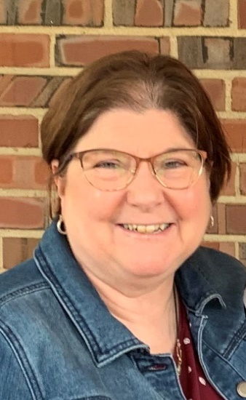

Teacher Background:
Jan Eyster (BS and MS in El Ed)
Jan has been married to Rich for 32 years, and they are the parents of two young adult children (Jonathan age 22 and Kate age 20). Jan taught at Heritage Christian School in Indianapolis for 18 years, teaching in the Elementary, and later, one-on-one with students who struggled with a learning difference. She also has co-led Women’s Bible Studies, and teaches a Bible Class to grades 4-8 here at Wisdom Builder on Mondays, and World Geography for grades 4-8 on Tuesdays. Her love is teaching, and children, and studying the Word.
Teacher contact information:
E-mail: jreyster@comcast.net
Phone: 317-776-3742
M-F afternoons, leave a message if no answer, and I’ll return your call as soon as possible.

